**Assignment 5**

1. **What are the reasons for feature scaling?**

Ans:

Machine learning is like making a mixed fruit juice. If we want to get the best-mixed juice, we need to mix all fruit not by their size but based on their right proportion. We just need to remember apple and strawberry are not the same unless we make them similar in some context to compare their attribute. Similarly, in many machine learning algorithms, to bring all features in the same standing, we need to do scaling so that one significant number doesn’t impact the model just because of their large magnitude.

**Why do we need scaling?**

Machine learning algorithm just sees number — if there is a vast difference in the range say few ranging in thousands and few ranging in the tens, and it makes the underlying assumption that higher ranging numbers have superiority of some sort. So these more significant number starts playing a more decisive role while training the model.

The machine learning algorithm works on numbers and does not know what that number represents. A weight of 10 grams and a price of 10 dollars represents completely two different things — which is a no brainer for humans, but for a model as a feature, it treats both as same.

Suppose we have two features of weight and price, as in the below table. The “Weight” cannot have a meaningful comparison with the “Price.” So the assumption algorithm makes that since “Weight” > “Price,” thus “Weight,” is more important than “Price.”

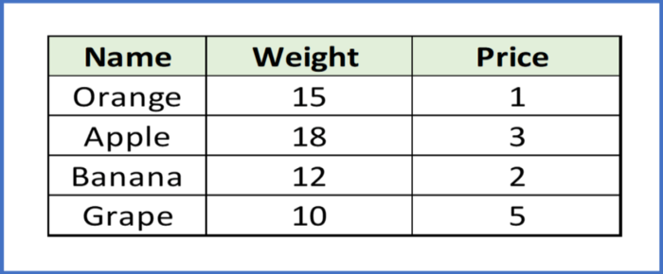

So these more significant number starts playing a more decisive role while training the model. Thus feature scaling is needed to bring every feature in the same footing without any upfront importance. Interestingly, if we convert the weight to “Kg,” then “Price” becomes dominant.

Another reason why feature scaling is applied is that few algorithms like Neural network gradient descent **converge much faster** with feature scaling than without it.

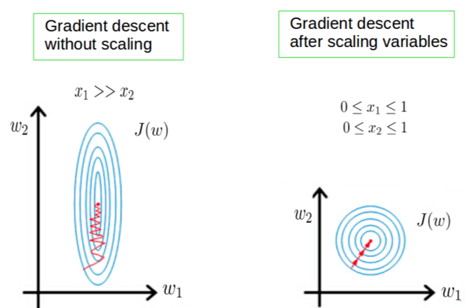

One more reason is **saturation**, like in the case of sigmoid activation in Neural Network, scaling would help not to saturate too fast.

**When to do scaling?**

Feature scaling is essential for machine learning algorithms that calculate **distances between data**. If not scale, the feature with a higher value range starts dominating when calculating distances, as explained intuitively in the “why?” section.

The ML algorithm is sensitive to the “**relative scales of features,**” which usually happens when it uses the numeric values of the features rather than say their rank.

In many algorithms, when we desire **faster convergence**, scaling is a MUST like in Neural Network.

Since the range of values of raw data varies widely, in some machine learning algorithms, objective functions do not work correctly without normalization. For example, the majority of classifiers calculate the distance between two points by the distance. If one of the features has a broad range of values, the distance governs this particular feature. Therefore, the range of all features should be normalized so that each feature contributes approximately proportionately to the final distance.

Even when the conditions, as mentioned above, are not satisfied, you may still need to rescale your features if the ML algorithm expects some scale or a saturation phenomenon can happen. Again, a neural network with saturating activation functions (e.g., sigmoid) is a good example.

Rule of thumb we may follow here is an algorithm that computes distance or assumes normality, **scales your features.**

1. **What is the difference between Feature Selection under Feature Engineering? Can you perform feature selection using regularization, if yes then how?**

**Ans**:

Feature engineering enables you to build more complex models than you could with only raw data. It also allows you to build interpretable models from any amount of data. Feature selection will help you limit these features to a manageable number.

1. **Suppose you are working on a Machine Learning problem, your training accuracy is lower than the testing accuracy, what can be the reason for this?**
2. **You are training a machine learning model, your training and the testing accuracy are decreasing, what can be the reason for this?**
3. **What solutions you can provide for optimal bias-variance levels in a machine learning problem?**